MINI PROJECT
BATCH-69
SERIC SUNIL

ORIGINAL DATASET SOURCE
https://www.kaggle.com/datasets/desolution01/messy-employee-dataset/data?utm_source=chatgpt.com

Introduction
For this project, I have selected a messy employee data to understand how Excel and Power BI can be used for data analysis. The dataset contains different employee-related information, which allows me to practise data cleaning, analysis, and visualisation using real-world data.
Objective
The main objective of this project is to clean and analyse employee data using Excel and Power BI, identify useful patterns and trends, and present the findings through simple and interactive visualisations.

EXCEL CLEANING
- At first, i have imported the data to excel for cleaning from Kaggle website
- I have checked for duplicates but couldn’t find any
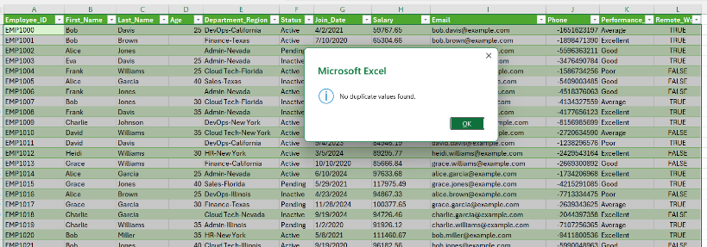
- I have joined the first name and last name of the employee and split the department and region. I have done both by using flash fill technique.
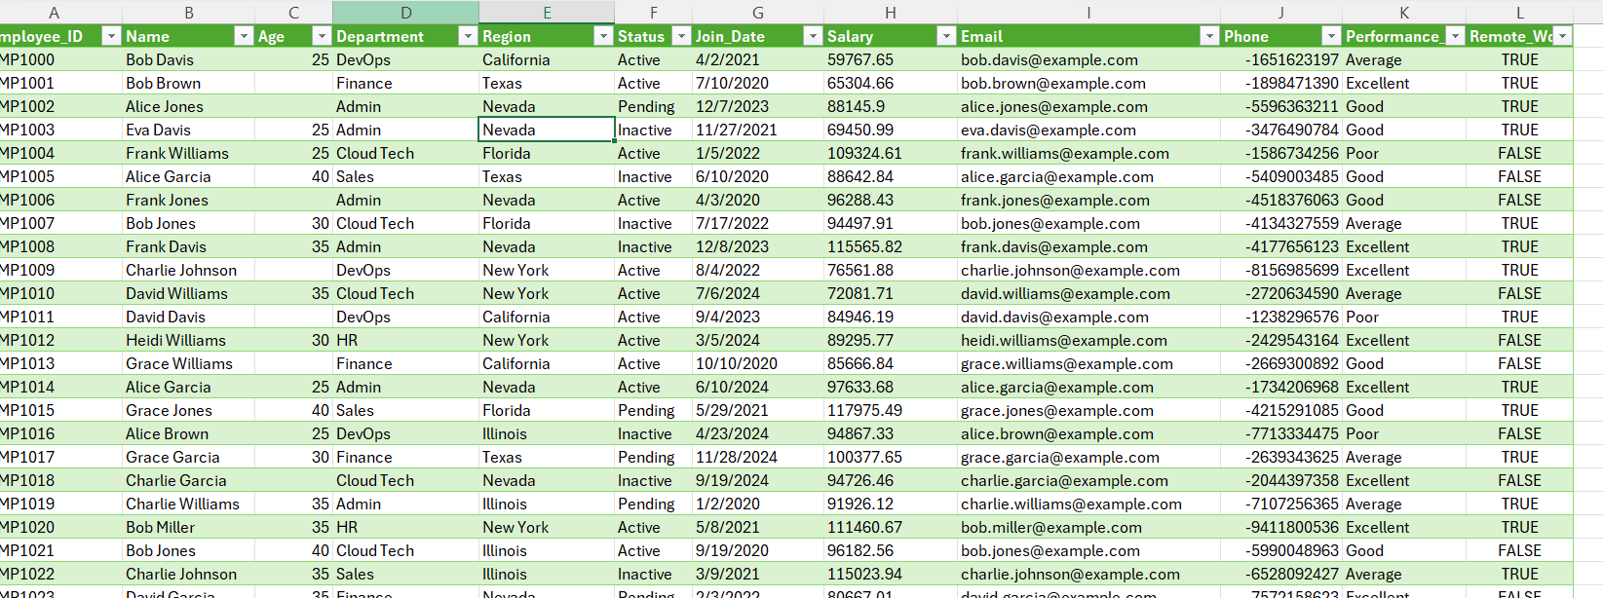
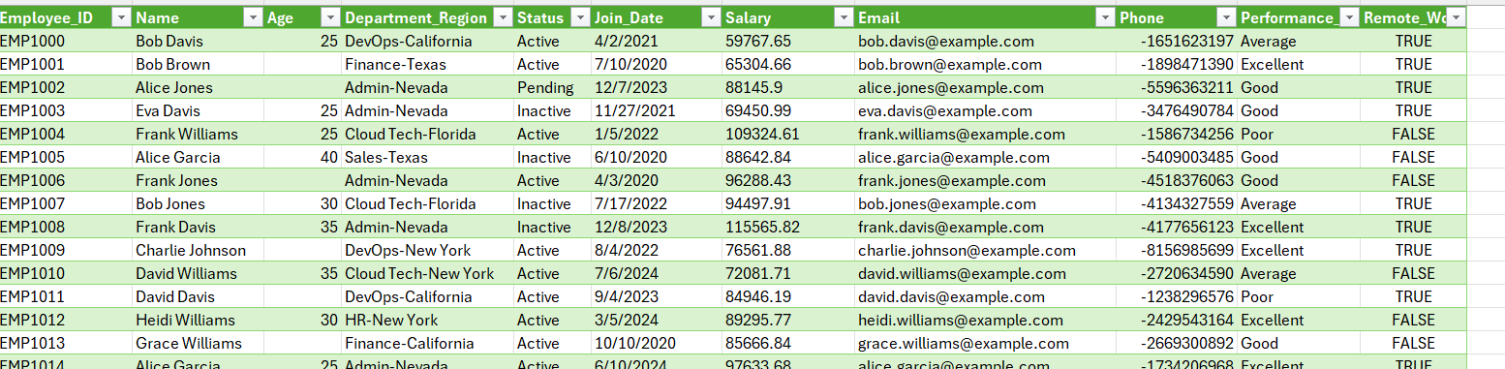

- I have found missing values in age category and salary column. I replaced missing values in age column using find and replace for blanks with N/A.
For missing values in salary column, I found descriptive statistics and then used calculated mean to replace blanks in it.
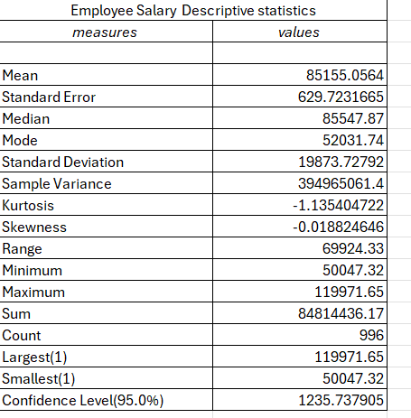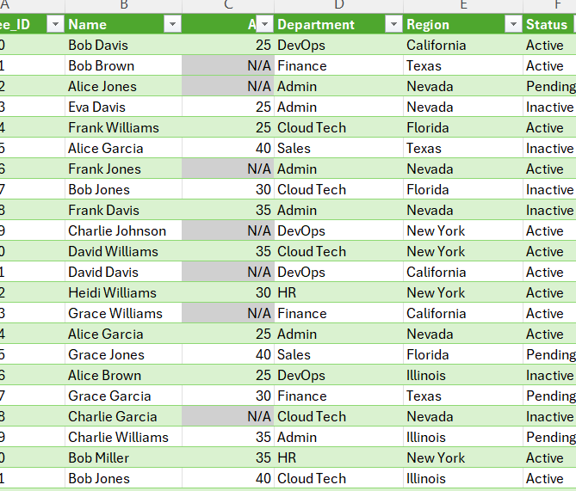
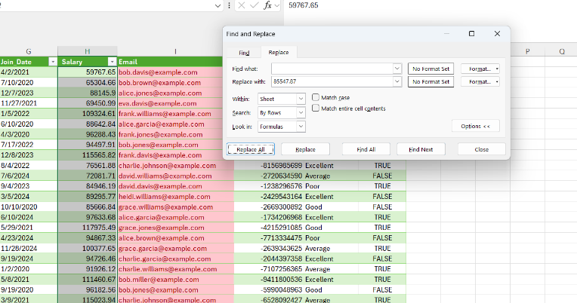

- I have changed join date column data type using power query in excel. I tried to do it in excel tab but was complicated. Hence, I used locale in power query.
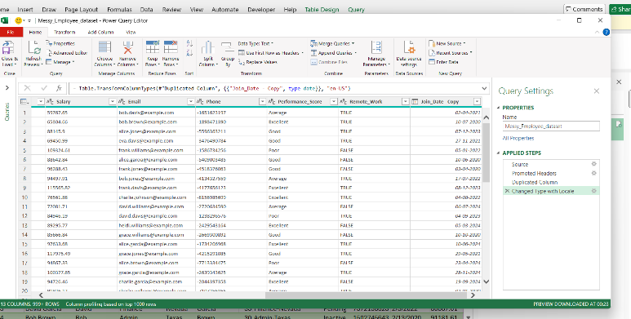
- All the mail column values were duplicates but overall, when you consider rest of columns, it is different. Hence, I took a new sheet, used unique function to take each email value only once and used countif function to calculate number of occurrences.
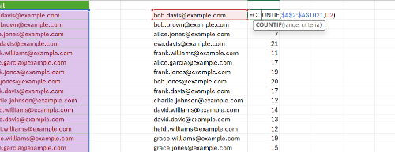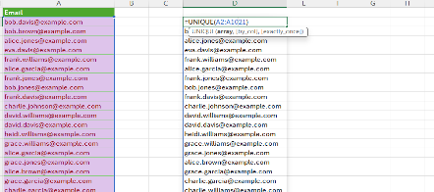

- I used conditional formatting to easily depict status column. Also, I changed phone column type using flash fill
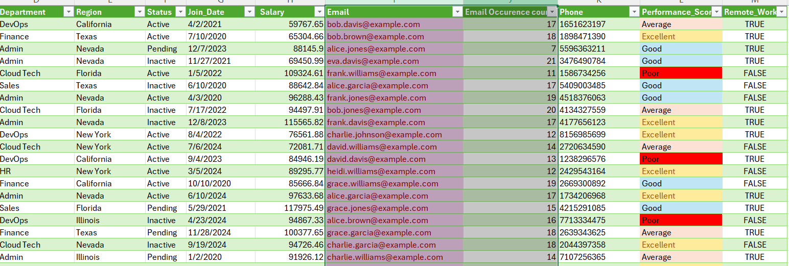

- I made employee data analytics report using pivot tables using datas from the cleaned table.
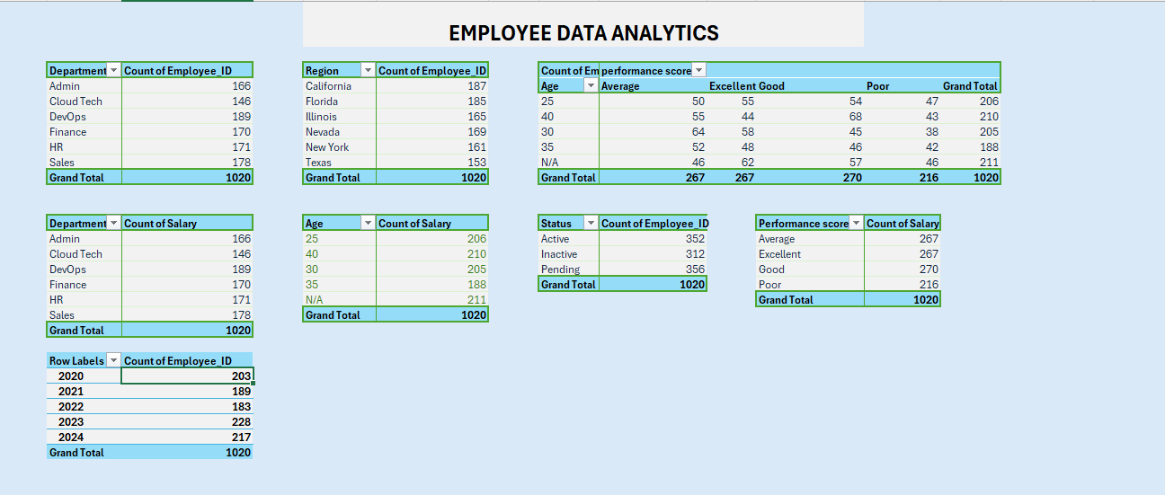

- I have made dashboard in excel with slicers and timelines using charts from pivot tables
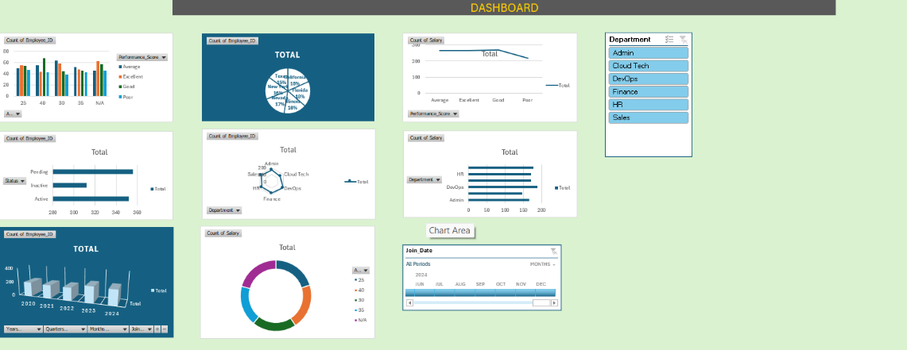

Note
I have not made detailed explanations of report and dashboard in excel because it is required in power query.

POWER BI

